**Intelligent Health Monitoring through Dietary Analysis**

**Sapan Patel**

**27-02-2024**

**(Task-0)**

**Abstract:**

This research pioneers personalized health management using machine learning for dietary analysis. The system examines users' diets, predicts health risks, and issues personalized alerts. It features detailed dietary data collection, advanced nutritional analysis, and continuous learning for adaptability. The user-friendly interface provides insights and recommendations, empowering individuals for informed health decisions. This project aims to inspire healthier lifestyles, contributing to disease prevention through proactive measures, marking a new paradigm in healthcare.

1. **Problem Statement:**

In contemporary healthcare, there is a growing need for innovative solutions that empower individuals to actively manage their health. The traditional approach to health monitoring often lacks personalization and proactive insights. To address this gap, the project focuses on developing an intelligent health monitoring system utilizing machine learning techniques for dietary analysis.

1. **Market/Customer/Business Need Assessment:**

As Market Base:

The market for intelligent health monitoring through dietary analysis is driven by a growing awareness of the impact of lifestyle on health. With a focus on preventive healthcare, there is a rising demand for solutions that leverage technology, including machine learning, to provide personalized insights based on dietary habits. This market encompasses wearable devices, health and wellness apps, and a trend toward personalized medicine. Data privacy and integration with healthcare providers are key considerations in this dynamic landscape. As of January 2022, the market reflects a shift towards holistic health monitoring, with an emphasis on individualized and technology-driven solutions.

As Customer/Business Need Assessment:

Customer and business needs for Intelligent Health Monitoring through Dietary Analysis are aligned with the increasing demand for personalized health insights. Customers seek actionable information, user-friendly interfaces, and empowerment through knowledge about their dietary choices. The business landscape values a competitive edge, long-term user engagement, and the potential for data-driven health services. The emphasis on preventive healthcare, technology integration, and addressing data privacy concerns positions solutions in this market to meet evolving customer and business requirements, reflecting a promising intersection of health and technology trends.

1. **Target Specifications and Characterization:**

Target specifications for Intelligent Health Monitoring through Dietary Analysis involve creating a system capable of detailed dietary data collection, employing advanced machine learning algorithms for nutritional analysis, and establishing a predictive model for health risks based on dietary correlations. The system's user-friendly interface should offer personalized alerts and recommendations. Continuous learning mechanisms must be in place for adaptability to changing dietary preferences and user feedback. Characterization involves positioning the solution as a comprehensive, personalized, and technology-driven tool for empowering individuals to make informed health decisions through dietary insights. The goal is to provide a holistic health monitoring experience that aligns with evolving trends in healthcare and technology.

1. **External Search:**

The dataset is available on National library of Medicine and focuses on dietary habits. It includes information about the nutritional distance between the initial and final dietary choices, along with the type of food consumed. The references for the dataset are provided below.

<https://issai.nu.edu.kz/wp-content/themes/issai-new/data/models/CAFD/CAFD.zip>

In contemporary times, individuals commonly document their food consumption by sharing images on social media platforms. Capitalizing on this prevalent behavior, the real-time recognition and accurate classification of these food images hold significant potential in simplifying the recording of food diaries and facilitating personalized dietary interventions. Despite the rich cultural and historical distinctiveness of Central Asian cuisine, there is a noticeable scarcity of published data on the food and dietary practices in this region. Addressing this void, our objective is to establish a reliable and easily accessible dataset of regional foods for both public consumers and researchers. To our knowledge, this marks the pioneering effort in creating the Central Asian Food Dataset (CAFD). Comprising 42 distinct food categories and featuring over 16,000 images showcasing the unique national dishes of the region, the dataset serves as a comprehensive resource. Employing the ResNet152 neural network model, we achieved a notable classification accuracy of 88.70% across the 42 classes on the CAFD. The success of our food recognition models, trained on the CAFD, underscores the effectiveness and high accuracy of computer vision in dietary assessment.

**Keywords:** nutritional intervention, computer vision, food classification, Central Asian food, dietary assessment, food recognition, AI, Central Asia, food dataset

1. **Bench marking alternate products:**

Benchmarking alternate products in Intelligent Health Monitoring through Dietary Analysis involves assessing accuracy, data integration, personalization, user-friendliness, real-time monitoring, security, cost, clinical validation, scalability, and customer support. This comparison helps identify strengths and weaknesses to determine the most effective and suitable solutions for personalized health monitoring based on dietary analysis.

1. **Applicable Patents:**

G16H50/20 - ICT specially adapted for medical diagnosis, medical simulation or medical data mining; ICT specially adapted for detecting, monitoring or modelling epidemics or pandemics for computer-aided diagnosis, e.g. based on medical expert systems

1. **Applicable Regulations:**
2. General Data Protection Regulation (GDPR):
   * Applicable in the European Union, GDPR sets standards for the protection and processing of personal data, including health-related information. Compliance ensures the secure handling of individuals' data.
3. Health Insurance Portability and Accountability Act (HIPAA):
   * In the United States, HIPAA establishes rules for safeguarding and managing protected health information (PHI). Compliance is essential for healthcare providers and technology solutions handling sensitive health data.
4. Medical Device Regulations (FDA, CE Marking):
   * Adherence to regulations from the U.S. Food and Drug Administration (FDA) or obtaining CE marking in the European Union is crucial if the monitoring system involves medical devices. This ensures safety and efficacy.
5. Telemedicine Regulations:
   * Various countries have specific regulations governing telemedicine and remote patient monitoring. Compliance with these regulations is important to maintain proper standards of care and protect patient privacy in remote healthcare services.
6. **Applicable Constraints:**
7. **Cloud Storage for Data:** Utilizing cloud platforms ensures secure storage and accessibility of health data collected online, facilitating efficient data management and scalability in our health monitoring project.
8. **Spark Service for Data Cleaning:** Employing Spark service enables robust data cleaning and transformation, enhancing the quality and reliability of the health data processed in our project.
9. **Visualization with Tableau and PowerBI:** Evaluation of our model is streamlined through Tableau and PowerBI, providing insightful visualizations that aid in understanding and interpreting the health monitoring data effectively.
10. **Modeling Techniques - SARIMAX and Linear Regression:** The application of SARIMAX for time series analysis and linear regression for modeling contributes to the precision and effectiveness of our health monitoring system's predictive capabilities.
11. **Business Model:**

The business model for Intelligent Health Monitoring through Dietary Analysis involves offering a subscription-based platform or mobile application that provides personalized health insights. Users would upload images or input dietary data, and the system, powered by machine learning, would analyze nutritional content and patterns. Revenue streams could include subscription fees, premium features, and partnerships with healthcare providers or nutrition services. The model aims to attract users seeking proactive health management, personalized dietary recommendations, and a convenient way to monitor their well-being through advanced technology.

1. **Concept Generation:**

Concepts for Intelligent Health Monitoring through Dietary Analysis include creating an AI-driven platform that seamlessly integrates with users' daily lives. The platform employs machine learning models for real-time food recognition, nutritional analysis, and personalized health insights. Features may include a user-friendly mobile app for easy data input, a gamified system to enhance engagement, and integration with wearable devices for comprehensive health tracking. The concept aims to revolutionize dietary monitoring by leveraging advanced technology, fostering proactive health management, and offering a holistic solution for personalized well-being.

1. **Concept Development:**

IMHMS collects patient's physiological data through the bio-sensors. The data is aggregated in the sensor network and a summary of the collected data is transmitted to a patient's personal computer or cell phone/PDA. These devices forward data to the medical server for analysis. After the data is analyzed, the medical server provides feedback to the patient's personal computer or cell phone/PDA. The patients can take necessary actions depending on the feedback. The IMHMS contains three components. They are

1. Wearable Body Sensor Network [WBSN]

2. Patients Personal Home Server [PPHS]

3. Intelligent Medical Server [IMS].

1. **Final Product Prototype with Schematic Diagram:**

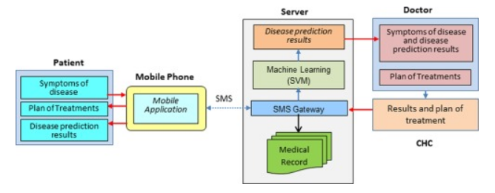

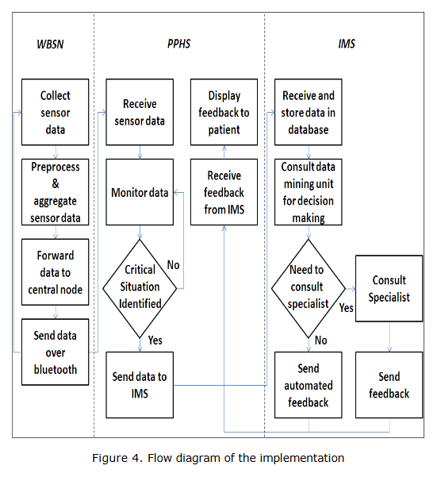

1. **Product Details:**

* **How does it work**

**Wearable Body Sensor Network [WBSN]**

A Wearable Body Sensor Network (WBSN) comprises wearable or implantable bio-sensors in a patient's body. These sensors collect organ-specific readings, which are sent to group leaders. Group leaders communicate and aggregate information, forwarding it to the central controller. The central controller transmits patient data to a personal computer or mobile device using wireless protocols such as Bluetooth, WLAN (802.11), or ZigBee. ZigBee, known for its suitability in pervasive applications, is utilized for communication due to its specialized wireless capabilities.

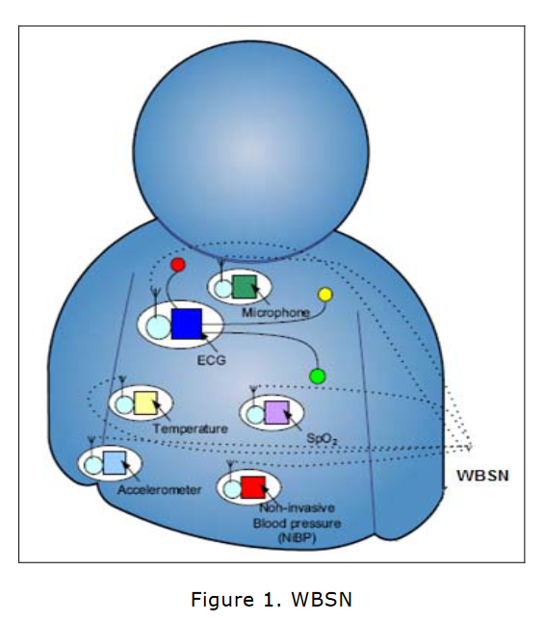

**Patient's Personal Home Server [PPHS]**

The Patient's Personal Home Server (PPHS) serves as a link between the wearable body sensor network (WBSN) and the Intelligent Medical Server (IMS). It collects data from the WBSN's central controller and decides whether to transmit it to the IMS. PPHS, ideally on mobile devices, communicates with IMS via GPRS/Edge/SMS, while the computer-based PPHS uses the internet. Implementing IMS through a Web Service or Servlet-based architecture ensures secure communication, enabling various heterogeneous environments to connect seamlessly to a single IMS.

**Intelligent Medical Server [IMS]**

The Intelligent Medical Server (IMS) acts as the central hub in the architecture, receiving data from all Patient's Personal Home Servers (PPHS). It employs advanced data mining techniques to learn patient-specific thresholds, utilizing methods like neural nets, association rules, and decision trees. IMS processes examination and treatment records, providing feedback to PPHS or alerting medical authorities in critical situations. IMS maintains patient-specific records, inferring trends and coping with health variations. It is controlled by specialized physicians, but patient input can help train IMS. Security is ensured through RFID tags for patient identification, allowing for remote data retrieval and ensuring patient confidentiality.

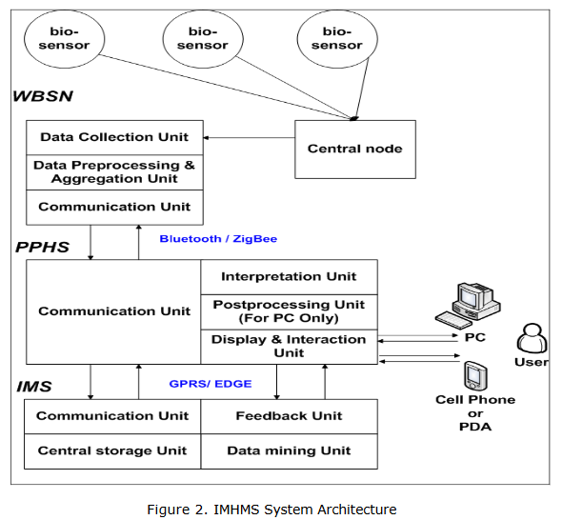

* **Data sources**

The dataset is available on National library of Medicine and focuses on dietary habits. It includes information about the nutritional distance between the initial and final dietary choices, along with the type of food consumed. The references for the dataset are provided below.

<https://issai.nu.edu.kz/wp-content/themes/issai-new/data/models/CAFD/CAFD.zip>

For More Documentation and Research Paper of Problem related

<https://www.researchgate.net/publication/220896597_Intelligent_mobile_health_monitoring_system_IMHMS>

* **Algorithms**

Convolutional Neural Networks (CNNs):

* Ideal for image recognition tasks, CNNs can be effective in analyzing food images and extracting features for dietary analysis.

Random Forests:

* Random Forests are versatile and can be used for classification tasks, such as categorizing different types of food. They work well with high-dimensional data.

1. **Conclusion:**

In conclusion, the implementation of an Intelligent Health Monitoring through Dietary Analysis system marks a significant advancement in the field of healthcare and wellness. The system, by leveraging sophisticated technologies such as artificial intelligence and machine learning, offers a personalized and data-driven approach to monitoring an individual's health through the analysis of dietary habits. The main objective of this system is to empower individuals to make informed decisions about their nutrition, leading to improved overall health outcomes.

One key aspect of this intelligent monitoring system is its ability to analyze dietary patterns and provide tailored recommendations based on individual health profiles. By utilizing real-time data and advanced algorithms, the system can identify trends, nutritional deficiencies, or excesses, and offer actionable insights to users. This not only enhances self-awareness but also promotes preventive healthcare, as users can proactively address potential health issues through adjustments in their dietary choices.

Furthermore, the system fosters a holistic approach to health by considering various factors such as lifestyle, preferences, and dietary restrictions. The integration of user-friendly interfaces and mobile applications makes it accessible and convenient for individuals to engage with their health data. In essence, Intelligent Health Monitoring through Dietary Analysis contributes to a paradigm shift from reactive healthcare to proactive well-being, placing individuals at the center of their health journey. As technology continues to evolve, the potential for further refinement and integration of such systems holds promise for a healthier and more informed global population.

1. **References:**

[1]A GOOD AGE: Aging and technology.

<http://ledger.southofboston.com/articles/2004/03/29/life/life02.txt>.

[2] Aware Home Homepage-Aware Home Research Institute at Georgia Tech.

<http://awarehome.imtc.gatech.edu/>.

[3] Center for Future Health. <http://www.centerforfuturehealth.org>.

[4] Centre for Pervasive Healthcare. <http://www.pervasivehealthcare.dk/>.

[5] Java Cryptography Extension.

<http://java.sun.com/j2se/1.4.2/docs/guide/security/jce/JCERefGuide.html>.

[6] Chatgpt.

<https://chat.openai.com/c/cbc09b20-acaf-42b4-bc12-5507cea812b5>